**Print custom Handling Unit label form using PPF framework in SAP EWM**

Print the custom handling unit label using transaction code: /N/SCWM/MON

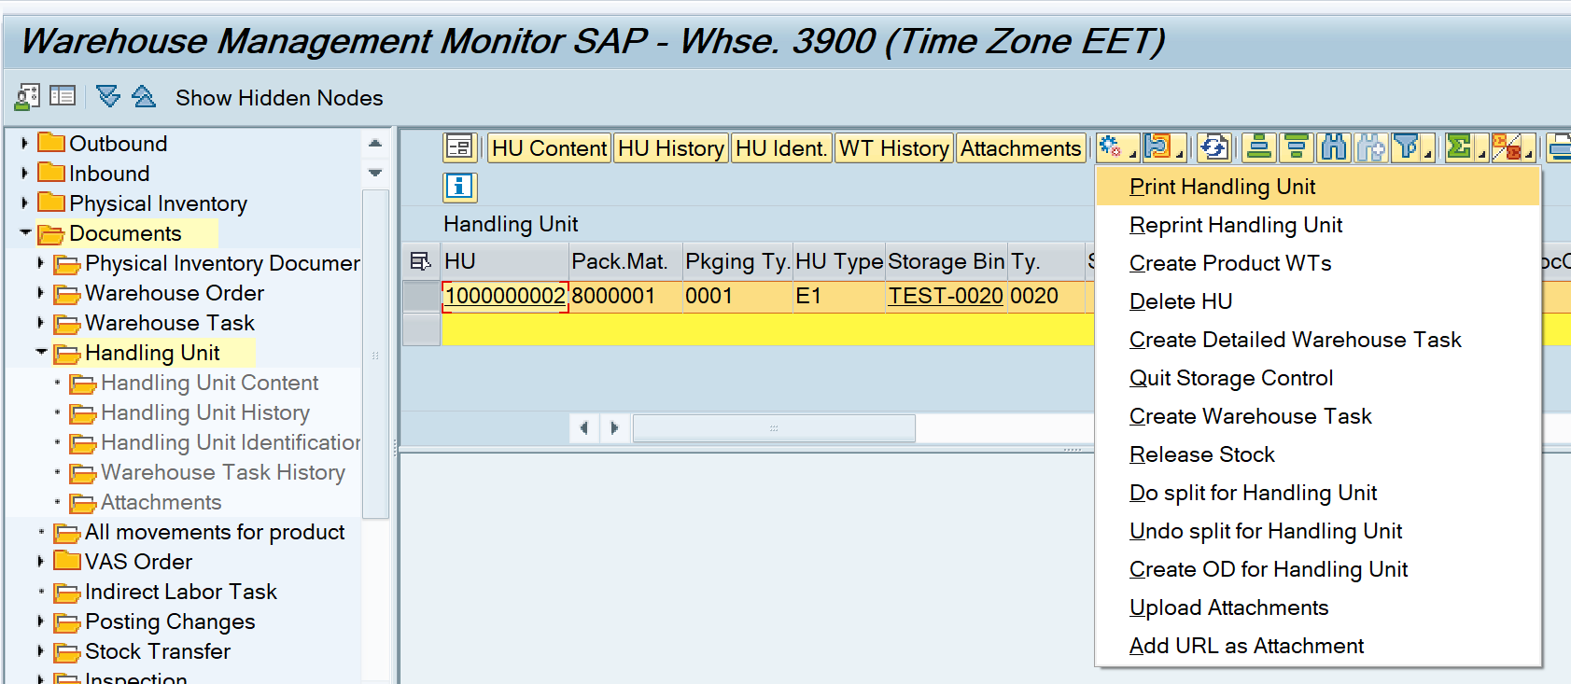

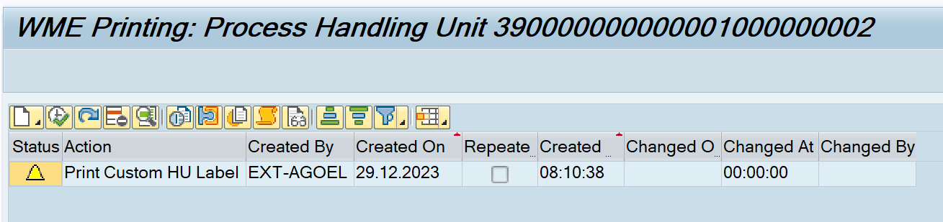

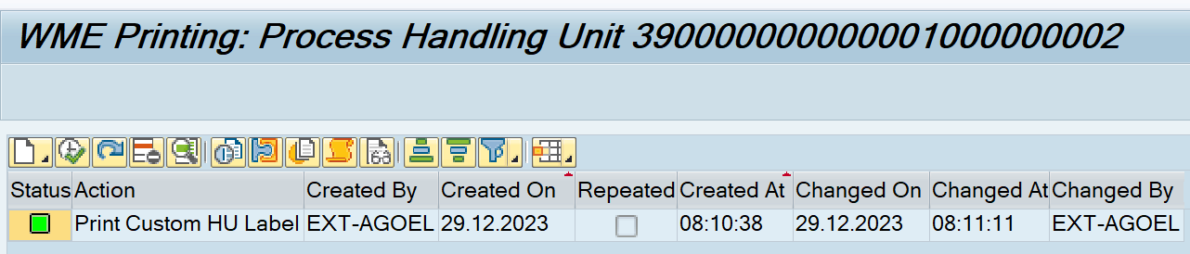

Spool request generated

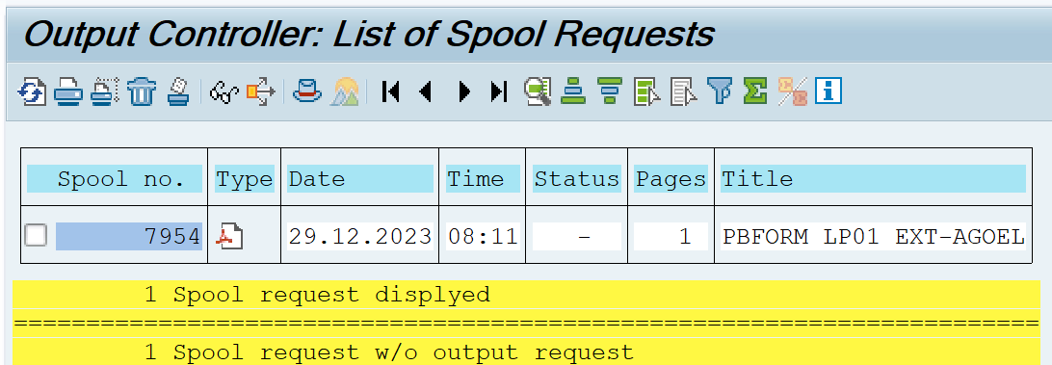

Form preview generated:

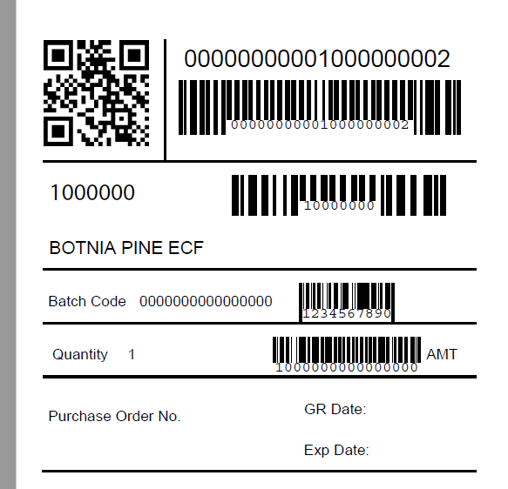

Technical details:

Custom action definition details:

Transaction code: SPPFCADM

Application: /SCWM/WME

Action Profile: /SCWM/HU

Action Definition: ZHU_LABEL

BADI Definition: EXEC_METHODCALL_PPF

BADI Implementation: ZEWM_EI_HU_LABEL

Method: EXECUTE

Adobe form: ZEWM_AF_HU_LABEL

Adobe form Interface: ZEWM_AFI_HU_LABEL

**Code in above BADI implementation**

  METHOD if_ex_exec_methodcall_ppf~execute.  
*------------------------------------------------------------------------------------------  
*   This method check for HU identification id and pass it to generate the custom HU lable  
*   Form : ZEWM_AF_HU_LABEL  
*------------------------------------------------------------------------------------------  
  
    DATA:lv_error            TYPE string,  
         lv_huidentification TYPE /scwm/de_huident,  
         lv_warehouse_no     TYPE /scwm/lgnum,  
         lv_function_name    TYPE rs38l_fnam,  
         lt_hu_header        TYPE /scwm/tt_huhdr_int,  
         ls_output_params    TYPE sfpoutputparams,  
         ls_formoutput       TYPE fpformoutput,  
         lo_ao_hu            TYPE REF TO /scwm/cl_hu_ppf,  
         lt_shp_lable        TYPE /scwm/tt_shplabel,  
         lt_hu_details       TYPE /scwm/tt_wo_info,  
         lv_print_param      TYPE /scwm/s_print,  
         lt_hu_hierarchy     TYPE /scwm/tt_hu_print_tree,  
         lt_hu_hazard_mat    TYPE /scwm/t_hu_hazard_mat,  
         lt_material_items   TYPE /scwm/tt_hu_material,  
         lt_ser_labels       TYPE /scwm/tt_ser_label,  
         ls_fp_docparams     TYPE sfpdocparams.  
  
    IF io_appl_object IS BOUND.  
  
*Get reference to object -> /scwm/cl_hu_ppf  
      lo_ao_hu ?= io_appl_object.  
  
      IF lo_ao_hu IS BOUND.  
  
        TRY.  
*Get HU identification id  
            lv_huidentification = lo_ao_hu->get_huident( ).  
  
*Get warehouse number  
            lv_warehouse_no = lo_ao_hu->get_lgnum( ).  
  
            IF lv_huidentification IS NOT INITIAL.  
  
              TRY.  
*Get function name  
                  CALL FUNCTION 'FP_FUNCTION_MODULE_NAME'  
                    EXPORTING  
                      i_name     = 'ZEWM_AF_HU_LABEL'  
                    IMPORTING  
                      e_funcname = lv_function_name.  
  
                  IF lv_function_name IS NOT INITIAL.  
  
                    ls_output_params-reqnew   = abap_true.  
                    ls_output_params-preview  = ' '.  
                    ls_output_params-nodialog = abap_true.  
                    ls_output_params-device   = 'PRINTER'.  
                    ls_output_params-dest     = 'LP01'.  
  
*Job open  
                    CALL FUNCTION 'FP_JOB_OPEN'  
                      CHANGING  
                        ie_outputparams = ls_output_params  
                      EXCEPTIONS  
                        cancel          = 1  
                        usage_error     = 2  
                        system_error    = 3  
                        internal_error  = 4  
                        OTHERS          = 5.  
                    IF sy-subrc NE 0.  
                      rp_status =  '2'.  
                      RETURN.  
                    ENDIF.  
  
                    APPEND INITIAL LINE TO lt_hu_header ASSIGNING FIELD-SYMBOL(<lfs_hu_header>).  
                    IF <lfs_hu_header> IS ASSIGNED.  
                      <lfs_hu_header>-huident = lv_huidentification.  
                      <lfs_hu_header>-lgnum   = lv_warehouse_no.  
                    ENDIF.  
  
*Call adobe form  
                    CALL FUNCTION lv_function_name  
                      EXPORTING  
                        /1bcdwb/docparams  = ls_fp_docparams  
                        hu_details         = lt_hu_details  
                        shp_label          = lt_shp_lable  
                        hu_header          = lt_hu_header  
                        print_param        = lv_print_param  
                        hu_hierarchy       = lt_hu_hierarchy  
                        it_hu_hazard_mat   = lt_hu_hazard_mat  
                        material_items     = lt_material_items  
                        it_ser_labels      = lt_ser_labels  
                      IMPORTING  
                        /1bcdwb/formoutput = ls_formoutput  
                      EXCEPTIONS  
                        usage_error        = 1  
                        system_error       = 2  
                        internal_error     = 3  
                        OTHERS             = 4.  
                    IF sy-subrc <> 0.  
                      rp_status =  '2'.  
                      RETURN.  
                    ENDIF.  
  
*Job close  
                    CALL FUNCTION 'FP_JOB_CLOSE'  
                      EXCEPTIONS  
                        usage_error    = 1  
                        system_error   = 2  
                        internal_error = 3  
                        OTHERS         = 4.  
                    IF sy-subrc <> 0.  
                      rp_status =  '2'.  
                      RETURN.  
                    ELSE.  
                      rp_status = '1'.  
                    ENDIF.  
  
                  ENDIF.  
  
                CATCH cx_fp_api INTO DATA(lo_fp_api).  
                  rp_status =  '2'.  
                  RETURN.  
              ENDTRY.  
  
            ENDIF.  
          CATCH cx_os_object_not_found.  
            rp_status =  '2'.  
            RETURN.  
        ENDTRY.  
  
      ENDIF.  
    ENDIF.  
  
  ENDMETHOD.

**BADI to implement custom schedule condition.**

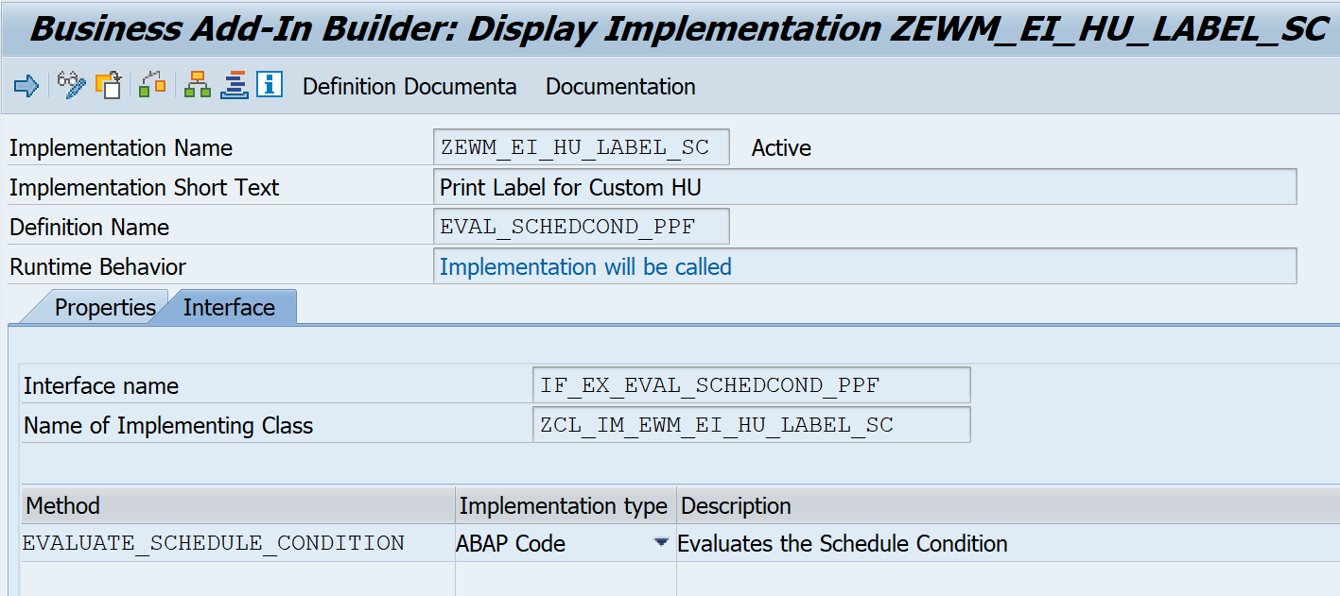

 METHOD if_ex_eval_schedcond_ppf~evaluate_schedule_condition.  
*----------------------------------------------------------------------------------------------------  
*   This method looks for custom schedule condition ZEWM_EI_HU_LABEL_SC to print the custom HU lable  
*   Form : ZEWM_AF_HU_LABEL  
*----------------------------------------------------------------------------------------------------  
  
    CALL FUNCTION '/SCWM/SCHEDULE_COND_HU'  
      EXPORTING  
        io_context   = io_context  
        ip_protocol  = ip_protocol  
        ip_ttype     = ip_ttype  
        flt_val      = flt_val  
        ii_container = ii_container  
      IMPORTING  
        ep_rc        = ep_rc.  
  
  ENDMETHOD.